Sonicwall NetExtender VPN Installation



* Step : 1

Navigate to the SonicWall VPN Clients page at https://www.sonicwall.com/products/remote-access/vpn-clients/.

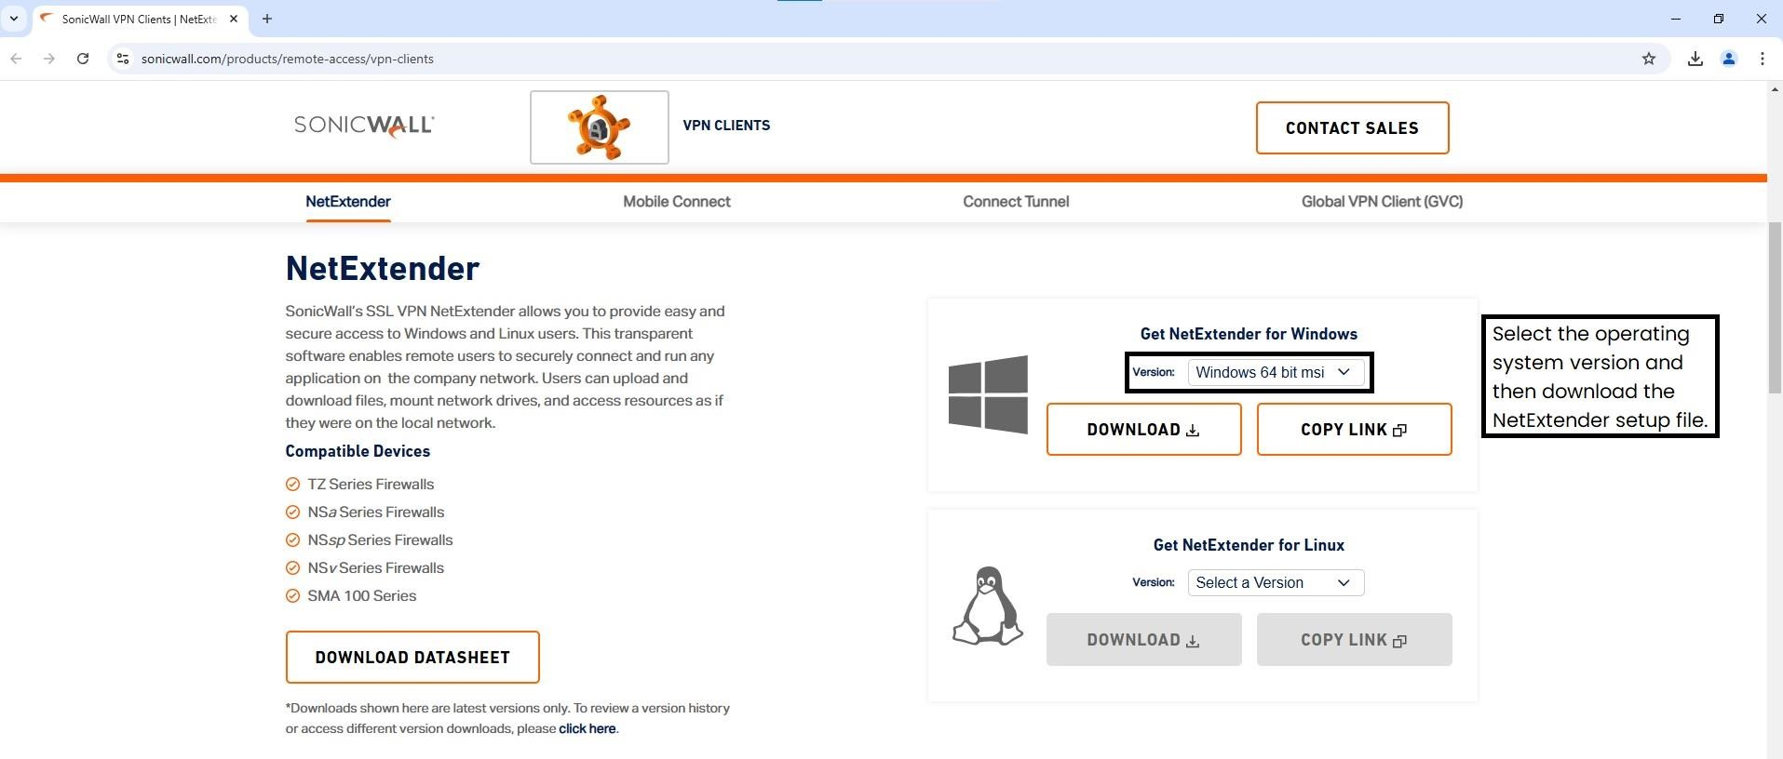

Or (Copy the url and paste on your browser)

Select **NetExtender** and under Get NetExtender for Windows, click **DOWNLOAD.**

* Step : 2

Kindly install the NetExtender VPN application by following below motioned steps.

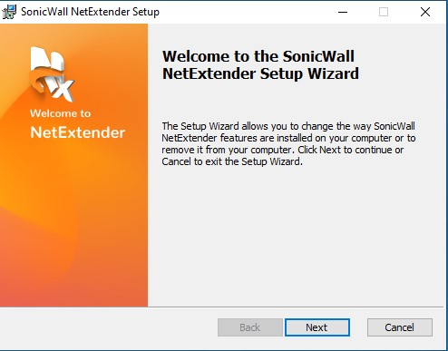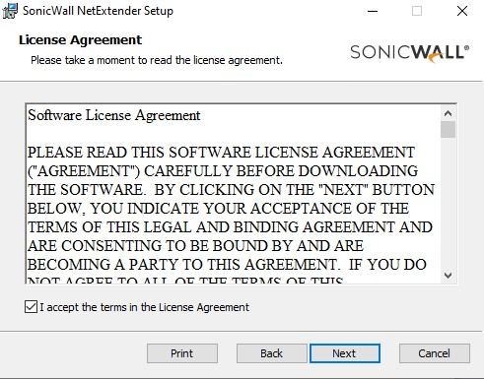

* Step : 3

After the installation, Launch the SonicWall NetExtender VPN.

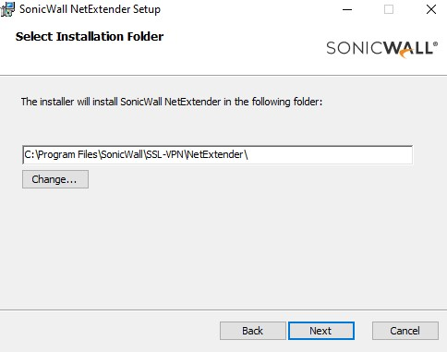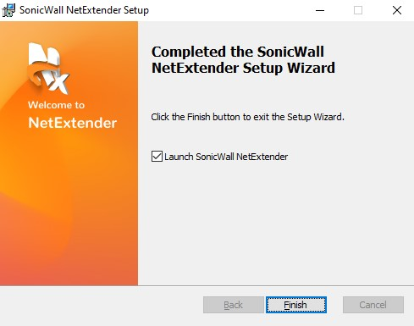

Navigate to the SonicWall VPN Clients page at https://vpn.changepond.com:4433/#/ Enter your Username and Password and then click “Login”.

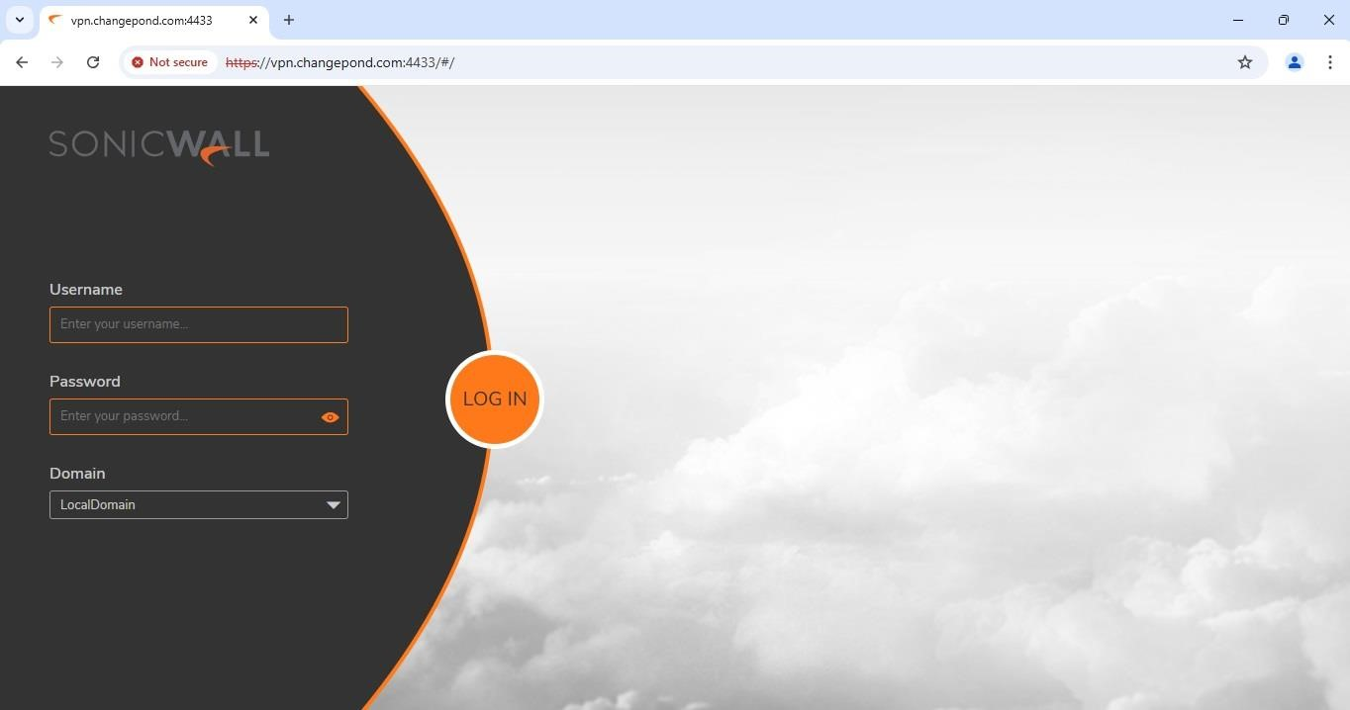

Download and install Google Authenticator on your mobile, and scan the QR code, then enter the 6-digit code in 2FA Code input field, and click “**OK**”.

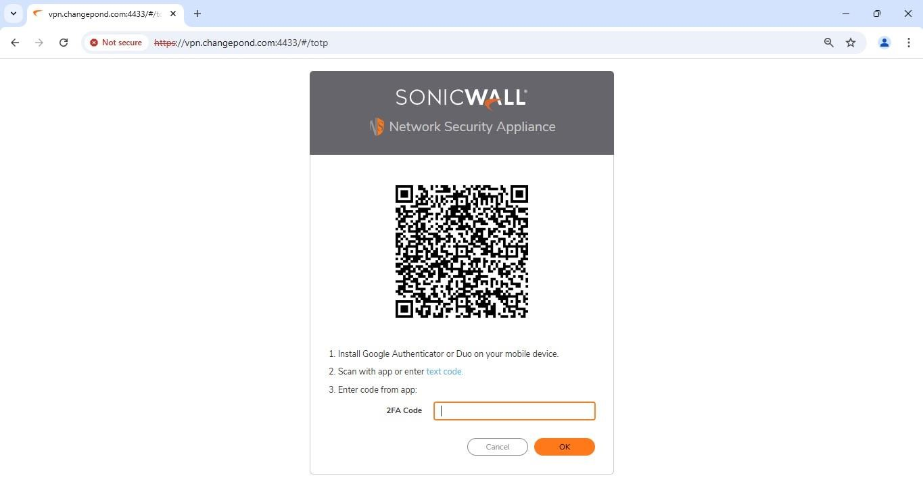

Once the setup is complete, the following screen will be redirect in the browser and click the “**Continue**” button.

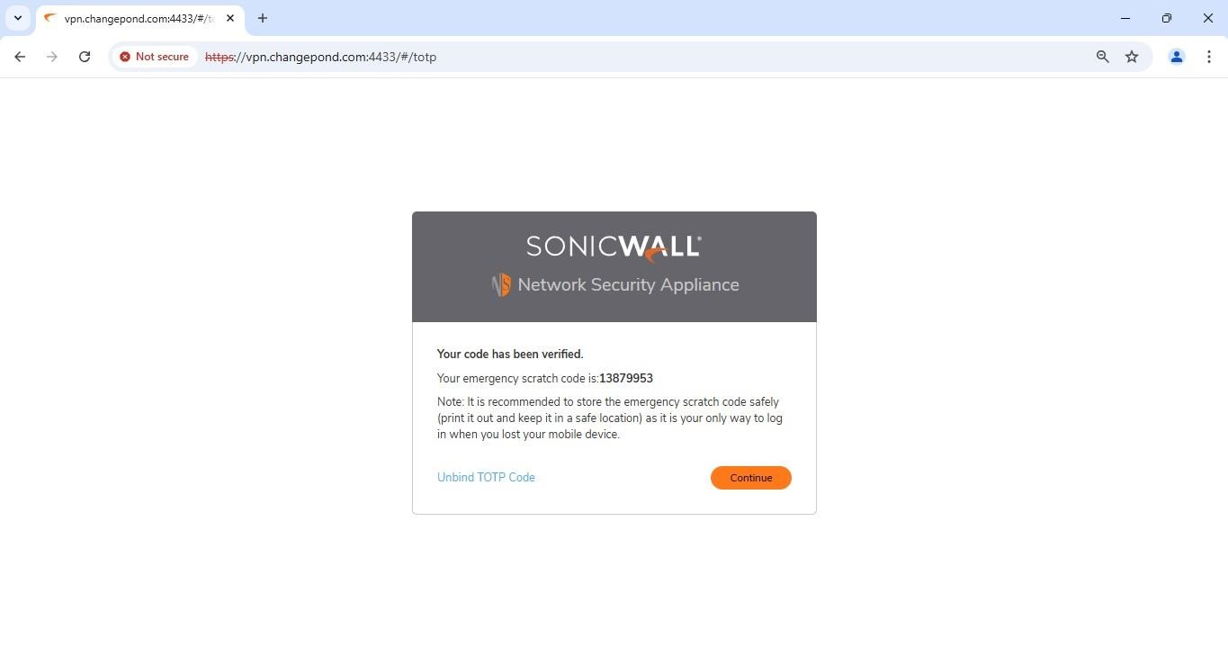

Open the NetExtender VPN application and click on the “Add Connection”.

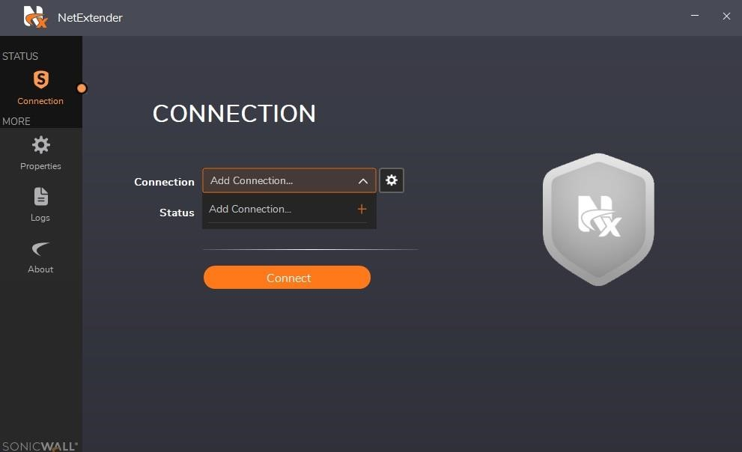

* Edit the connection Name : CPT_VPN and Server : vpn.changepond.com:4433
* After that enter the username and password which is provided by Sysadmin.
* Select the domain as “LocalDomain” and protocol as “Auto” and save the connection.

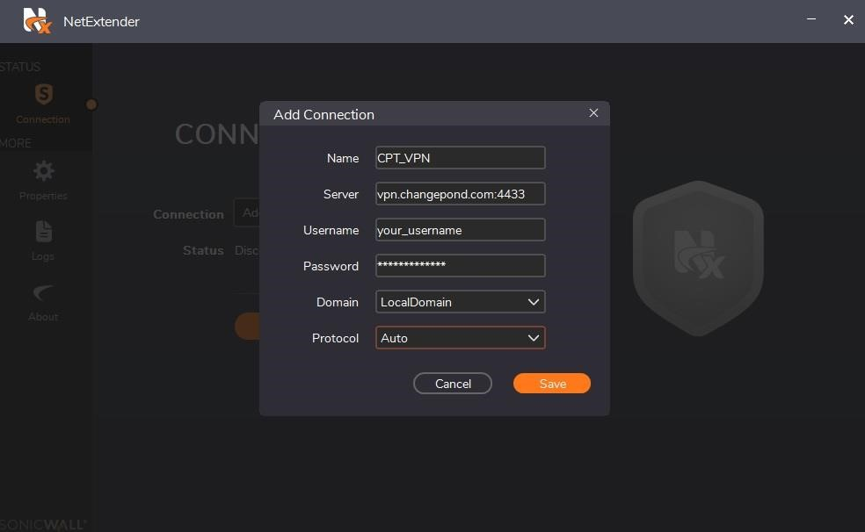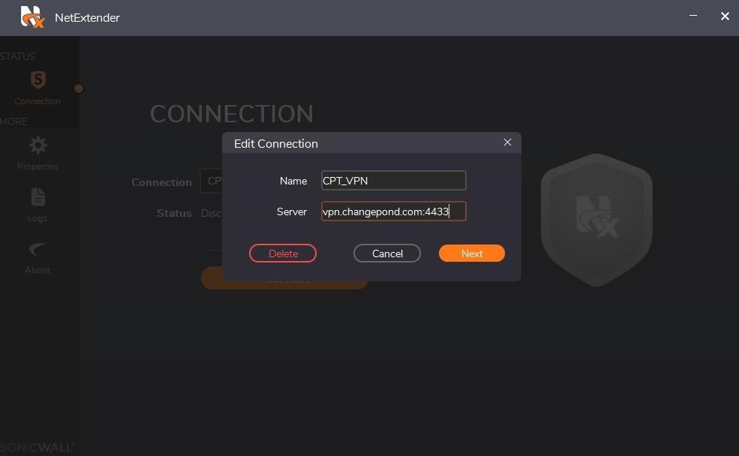

Step : 9

* Select the connection CPT_VPN and click the **Connect** button.

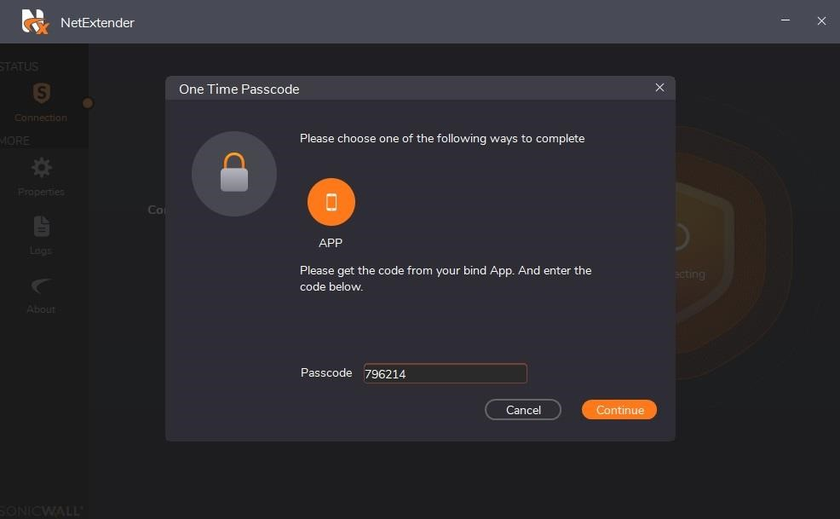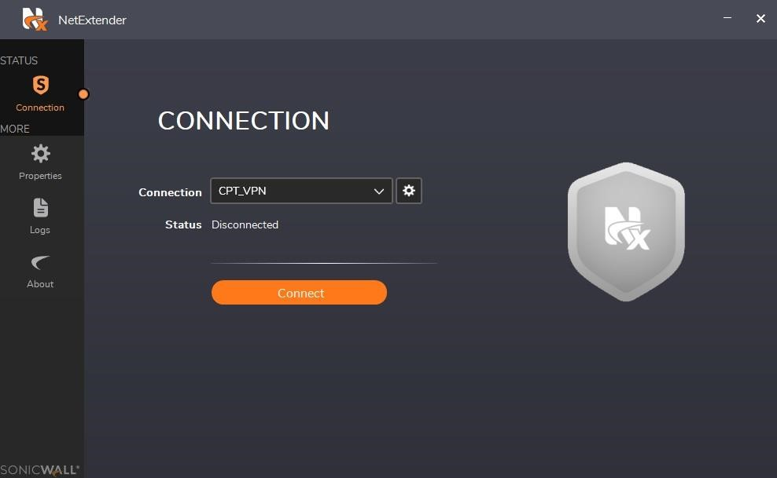

* And then enter the six digit password, which is generated on the Google Authenticator Application on the mobile and click the **Continue** button.

Step : 10

Once the connection established below screen will appear on the VPN application.

